INF10025 Data Management and Analytics

Tutorial 1 - Answers Sheet
Below you’ll find the tutorial content for Week 1. The questions relate to the material covered in the lectures in Week 1. You do NOT have to submit any of these answer for marking. However, some of the topics discussed within this document are similar to test 1 questions. The answers to these questions will also help you to have a better understanding database concepts – and to build the learning summary of your final portfolio submission.

1. A Database is a collection of data. Databases often have 'front-end' applications. What business applications have you used that has a database back-end and uses a front-end application to interact with the users?
=> The application of Swinburne University of Technology have used for a databse back-end uses a frone-end application to interact with users is the Student Portal:
- Front-end: The mobile app or website of student portal showcases following components including how many semester have learnt, what subjects have been enrolled and currently enrolling, calendar, fees and so on.
- Back-end: Storing student information such as First Name, Last Name, StudentID (VietNam/Australia), grade records, and address.
- Why it fits: When you click "Enrol", the front-end sends a request to the back-end database to add a new record to the Enrolment table and update class capacities in real time.

2. In Week 1, your lab instructor will also introduce you to Access. Is the Access interface intuitive for someone who knows nothing about databases? Why?
=> In my opinion, the Microsoft Access is partially inituitive cause:
- Visual GUI Environment: Access uses a Graphical User Interface (GUI) with ribbon menus, icons, and drag-and-drop features, which is far more accessible to beginners than writing raw SQL code.
- Spreadsheet-like Layout: Its Datasheet View presents data in familiar rows and columns, making it look and feel similar to a standard Microsoft Excel spreadsheet.
- Requires Underlying Database Knowledge: To build a working database, users must understand core relational concepts—such as defining Data Types, setting Primary Keys, and separating table structure (Design View) from data entry (Datasheet View).
- Unfamiliar Rules and Risks: Unlike Excel, edits made in Datasheet View are saved permanently automatically as soon as the cursor moves to another row, without displaying a confirmation prompt.
- Complex Tools: Features like the Query Design Grid require an understanding of logic rules (such as AND/OR criteria placement and wildcard search operators) that are not obvious simply by looking at the interface.

- MS Access has many reserved words. What are reserved words? Why do you need to know about reserved words?
=> Reserved words are specific keywords built into Microsoft Access and SQL engines that have predefined, special meanings reserved for system operations, functions, or commands (such as Date, Name, Select, Table, Number, Where, Order, Like, And, Or).
=> If using a reserved word as a table name or field name (for example, naming a column Date or Name), Access can misinterpret your field as a system command when executing queries, macros, or calculations.. Consequently, this action can lead to unexpected syntax errors or incorrect query results. Avoiding reserved words prevents naming conflicts and keeps database structures clean.

4. MS Access requires you to use / create tables. Each table has fields. Each field has datatypes. What is a datatype? What are commonly used datatypes?
=> A data type defines the specific kind of data that is allowed to be stored within a particular field/column of a table. It restricts invalid entries, determines storage size, and dictates what mathematical or logical operations can be performed on that field.
- Short Text: Used for alphanumeric text (such as names, titles, codes, or addresses).
- Number: Used for numeric values intended for mathematical calculations (e.g., quantities, runtimes, or scores).
- Currency: Used for monetary values, automatically formatted with currency symbols and decimal places.
- Date/Time: Used for storing calendar dates and times (e.g., date of birth or release dates).
- AutoNumber: Automatically generates sequential numeric values as new records are added (commonly used to assign key values).

- According to relational database theory, all tables should have a primary key. What is a primary key? Why is it important?
=> A Primary Key is a designated field (or combination of fields) in a table that contains a value serving as a unique identifier for each individual record/row.
- Uniqueness: It guarantees that no two records in a table are identical, as duplicate primary key values are strictly prohibited.
- Relational Database Theory: According to Codd's Relational Model, every table must have a primary key to uniquely distinguish records and establish valid relationships between tables.
- Data Integrity & Retrieval: It allows the database management system to accurately locate, update, or delete specific records without affecting other data.
- Value Stability: Primary key values must remain static and should never change over time

5. How is an Access Table different from an Access Query?
=> Access Table:
- Data Storage: A table is a permanent physical structure that actually stores raw data in a two-dimensional grid of rows (records) and columns (fields)[.
- Role: It acts as the primary data repository within the database.
=> Access Query:
- Data Retrieval: A query is a saved "question" asked of the database to extract, filter, sort, or calculate specific records based on defined criteria.
- Dynamic Output: A query does not store independent raw data of its own; instead, it dynamically pulls and displays data from one or more underlying tables (or other queries) when executed.
- Reusability: Unlike temporary datasheet filters, queries are saved as database objects and can be re-run repeatedly whenever updated results are needed

6. True or False
- Every table in a relational database should have a Primary Key => True
- A table may have more than one Primary Key => False
- A Primary Key must not have a NULL value => True
- Every Primary Key must be unique within a single table => True
- Two different tables may not have rows with the same Primary Key value => False
- A table must have a minimum of 3 columns => False
- A table may not have zero rows => False
- A table may have not more than 1 million rows => False

7. Consider a Query with the criteria "Chair" on the column called ProdName Indicate which of the following Product names would be a match?
- ChaiR
- Rocking Chair
- Chairlift

8. Consider a Query with the criteria Like "Ed*" on the column called StudentName Indicate which of the following Product names would be a match

- E.D.
- Ed
- EDDIE
- Edina

9. Consider a Query with the criteria Like "t*" on the column called ProdName Indicate which of the following Product names would be a match
- Table
- Wooden Table
- Red table
- Ttable

10. Consider a Query with the criteria Like "*E*" on the column called EmpName Indicate which of the following Employee names would be a match
- Peter
- EVE
- steve
- Amelia

11. Consider a Query with the criteria Like "*r" on the column called EmpName Indicate which of the following Employee names would be a match
- Peter
- Richard
- Emma
- Roger
12. Consider a Query with the criteria Like "*e*d*" on the column called EmpName Indicate which of the following Employee names would be a match
  - Edward
  - Teddy
  - Diane
  - Peter Davies

Consider this table named CUST_SMALL
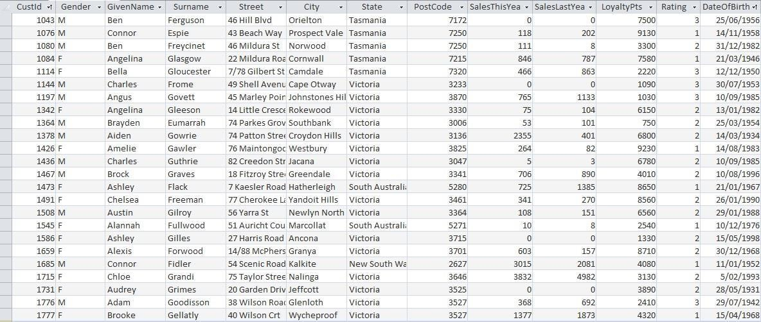

Without using any software, determine how many rows are selected by each of the following queries:
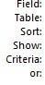
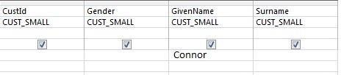

=> In the Criteria row, the GivenName field contains "Connor". Therefore, the query filters all records where GivenName = "Connor". There are 2 matching records, so the result is 2 rows.

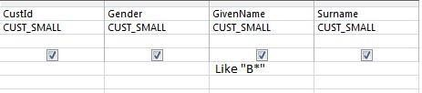

=> Result: 4 rows

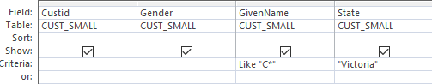
=> Result: 4 rows

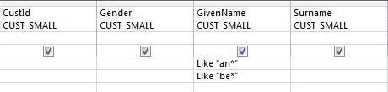

=> Result: 5 rows
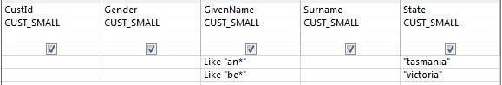
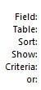

=> Answer: 1 row

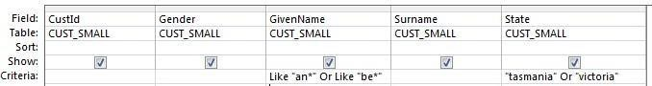

=> Result: 5 rows

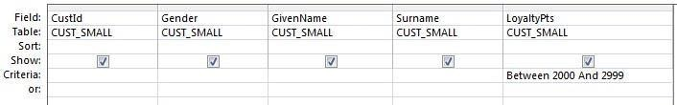
=> Result: 3 rows

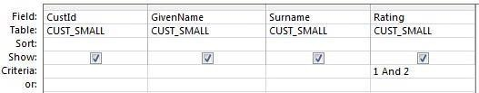

=> Result: 0 rows

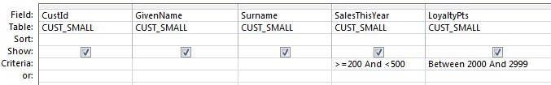
=> Answer: 2 rows

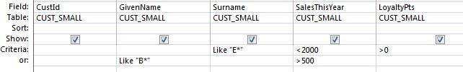

=> Answer: 2 rows
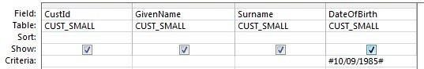

=> Answer: 0 row

…now continue with completing the first parts of Task 01.

